Google vs Google Scholar
Google : Searches for information from a variety of sources and web pages, including commercial ,government, non-profit organizations, social media and ‘self-published’ content.
Google Scholar : Searches for scholarly or research materials on multidisciplinary and cross-disciplinary topics from authoritative websites, such as academic publishers, professional societies, online repositories and universities.
1. Go to Google (http://www.google.com)
2. At the Google search screen, type this search in the search box:
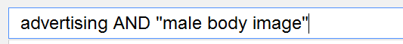
Use “” (quotation marks) to ensure that all search terms, in the exact sequence are found in the results retrieved.
The Boolean operator “AND” , “OR” must be in capital.
The * (asterisk) with quotation marks, means searching for the phrase “male image” (in this sequence) with some words in between :
For example, this will retrieve male body image

Refer to Google Support at http://support.google.com/websearch for more search tips
3. To obtain more relevant articles, add more search words such as synonyms.
4. Alternatively, click on the settings icon at the top right‐hand corner and select “Advanced Search”, or go to http://www.google.com/advanced_search.
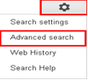

5. At the Advanced Search form, type in the search:
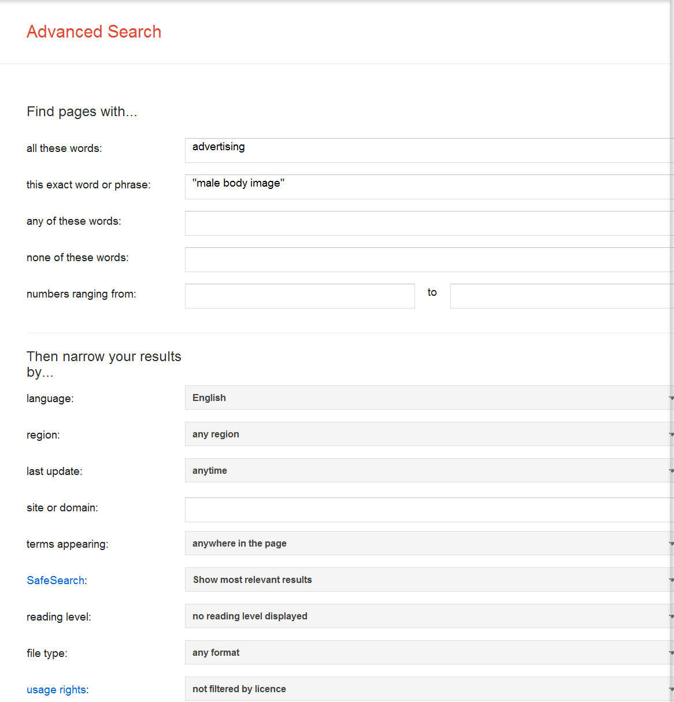
Narrow your search results by :
- Limit language : English
- .Limit site or domain :
- gov.sg (Singapore government only)
- edu (educational only)
- org (non-profit organisations only)
- Limit last updated date : past year or past month, etc.
- Limit file type : PDF, Powerpoint. Word document, etc.
6. To search Google Scholar, go to http://www.googlescholar.com.
7. At the Google Scholar search screen, try this search:
Click here for Advanced Search
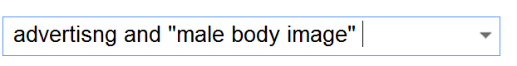
8. In Google Scholar Advanced Search, you may add more search words, for example, with the exact phrase “male body image”.

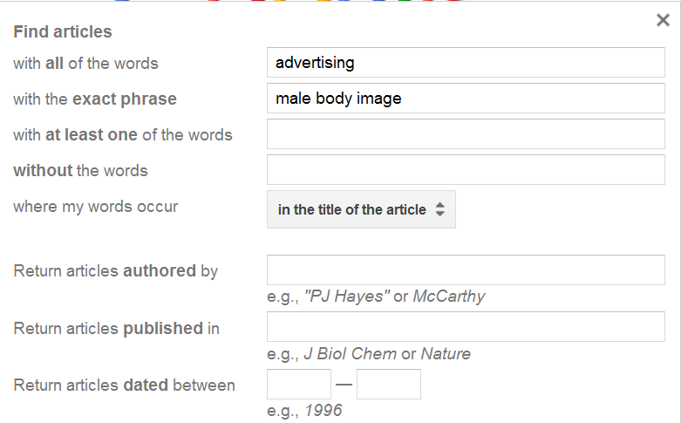
Limit the words to : “in the title of the article” retrieves more relevant results
Refer to Google Scholar help at http://scholar.google.com/intl/en/scholar/help.html
9. In order to check whether the full‐text article can be viewed online, you may try the following 2 methods:
Method 1 – Add Library Links to Google Scholar
a. At Google Scholar page, click “Settings” at the top right‐hand corner:
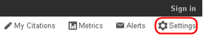
b. Select Library links on the left, type: national university of Singapore” and click search :
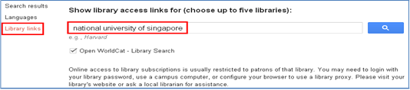
c. Tick as follows and click “Save”:
d. Once the settings are completed, when you conduct a search in Google Scholar, you
will see results like this :
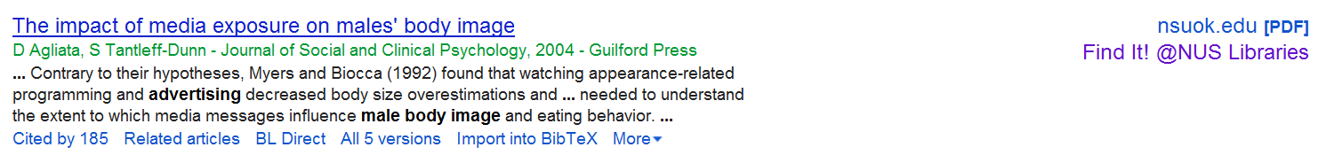
Click “Find It! @NUS Libraries” to view the full‐text article.
Method 2 – Add Proxy Bookmarklet to Internet Browser
a. For some articles retrieved from Google or Google Scholar search, you may be able to
view the full‐text of the articles online if the e‐journal title is included in the NUS
Libraries’ e-resource collection.
b. Please refer to the Library guide on proxy bookmarklet installation at
http://libguides.nus.edu.sg/proxy_bookmarklet.

** If you are encounter problems locating the full‐text, please contact the librarian:
Thavamani Prem Kumar (mani_kumar@nus.edu.sg), Umarani Jayapal (clbuj@nus.edu.sg)

